**Guidelines of Extended Abstract Preparation for 2018 6th International Workshop on Process Intensification (IWPI 2018)**

Cheng-Liang Chena and Da-Ming Wanga

a Department of Chemical Engineering

National Taiwan University, Taipei 10617 Taiwan

CCL@ntu.edu.tw

**Abstract**

This document serves as the template for all **extended abstracts** submitted to the **2018 6th International Workshop on Process Intensification (IWPI 2018). IWPI 2018 also includes the Symposium for Young ChemE Researchers for scholars whose age is below 40**, which aims at facilitating collaborations and strengthening connections among young generations. Each extended abstract is limited to **two pages**. All submissions will be sent for review. The accepted abstracts will be published in the Book of Abstracts in black and white. Please use this template when preparing your extended abstracts. This will ensure a uniform format in the publication. ***Please upload your extended abstracts via the conderence website*** (<http://IWPI2018.org>) ***before 30 June 2018****.* Should you have any query, please contact Conference Secretary, Professor Dun-Yun Kang ([dunyen@ntu.edu.tw](mailto:dunyen@ntu.edu.tw)), or Conference NOC Chair, Professor Cheng-Liang Chen ([CCL@ntu.edu.tw](mailto:CCL@ntu.edu.tw)). Please see the conference website on <http://IWPI2018.org> for further information.

**Preparation of Extended Abstract**

Abstracts should be written in **English**. The abstract shuold be limited to **two pages**. It should include a Tiltle, the information of Authors and Affiliations, the E-mail address of Corresponding Author, Keywords, Abstract. Throughout the abstract, use Times New Roman font with single spacing between lines. The recommended font size is 14 pts for the abstract title and 12 pts elsewhere. Other specific guidelines for each section are given below.

1. **Title:** Please provide a descriptive title of the abstract. The title should be concise and not span more than 2 lines. Use Times New Roman font with a font size of 14 pts and in boldface for the title.
2. **Authors and Affiliations:** Include the first name, middle initial and surnames of all the authors. The name of the corresponding author should be underlined. The affiliations of all the authors should be included. The e-mail of the corresponding author should be shown.
3. **Abstract:** Use Times New Roman font with a font size of 12 pts for the abstract.
4. **Keywords:** Provide up to 6 keywords, separated by semi-colons.
5. **Acknowledgements:** Any acknowledgements can be included at the end of the main body of the abstract but before the references.
6. **Citations and References:** In the text, refer to literature citations in the author-year format, *e.g.* [Author, 2015] or [Author 1 and Author 2, 2016] or [Author 1 *et al.*, 2017]. The references should be placed at the end of the abstract in the alphabetical order.

Table 1. Important dates of the IWPI 2018

|  |  |
| --- | --- |
| **Abstract (2 pages)** | 1 March - 30 June 2018 |
| **Acceptance Notification** | 31 July 2018 |
| **Early-bird Registration** | 30 Sep 2018 |
| **IWPI 2018** | 7-8 Nov 2018 |

Table 2. The International Program Committee of the IWPI 2018

|  |  |  |
| --- | --- | --- |
| **N. Ohmura** (Chair) | JP | Kobe University |
| **W.S. Kim** | KR | Kyung Hee University |
| **D.M. Wang** | TW | Natl Taiwan University |
| **R. Parthasarathy** | AU | RMIT University |
| **A. Raman** | MY | University of Malaya |
| **A. Harvey** | UK | Newcastle University |
| **H. Suzuki** | JP | Kobe University |
| **C. Fukuhara** | JP | Shizuoka University |
| **T. Horie** (Young ChemE Researchers) | JP | Kobe University |
| **J.W. Han** (Young ChemE Researchers) | KR | POSTECH |
| **D.Y. Kang** (Young ChemE Researchers) | TW | Natl Taiwan University |

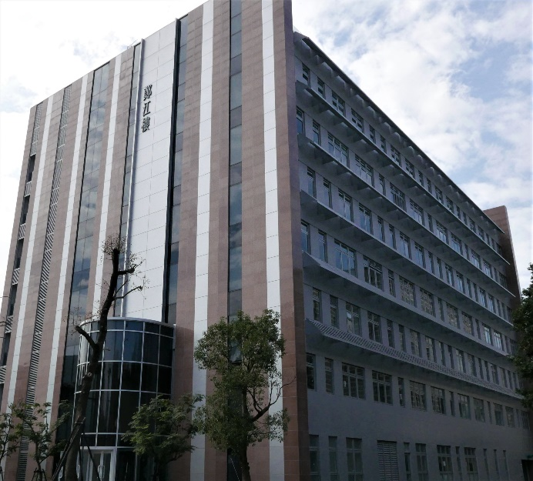

Figure 1. Photo of the conference venue, Cheng Jiang Hall, which is also the new building of Department of Chemical Engineering at National Taiwan Universiy.

**Acknowledgement:** The authors thank the Ministry of Science and Technology of Taiwan for supporting this research under the grant of MOST 104-2120-M-002-012.

**References**

1. Aguilar O., Perry S. J., Kim J.-K. and Smith R. Design and Optimization of Flexible Utility Systems Subject to Variable Conditions, Part 2: Methodology and Applications, *Chem Eng Res Des*, **85**, 1149-1168, 2007.
2. Bruno J. C., Fernandez F., Castells F. and Grossmann I. E. A Rigorous MINLP Model for The Optimal Synthesis and Operation of Utility Plants, *Chem Eng Res Des*, **76**, 246-258, 1998.